# OPEN CALL｜Hong Museum 2025 "Situated Resonance" Wenzhou Research Sponsorship Program

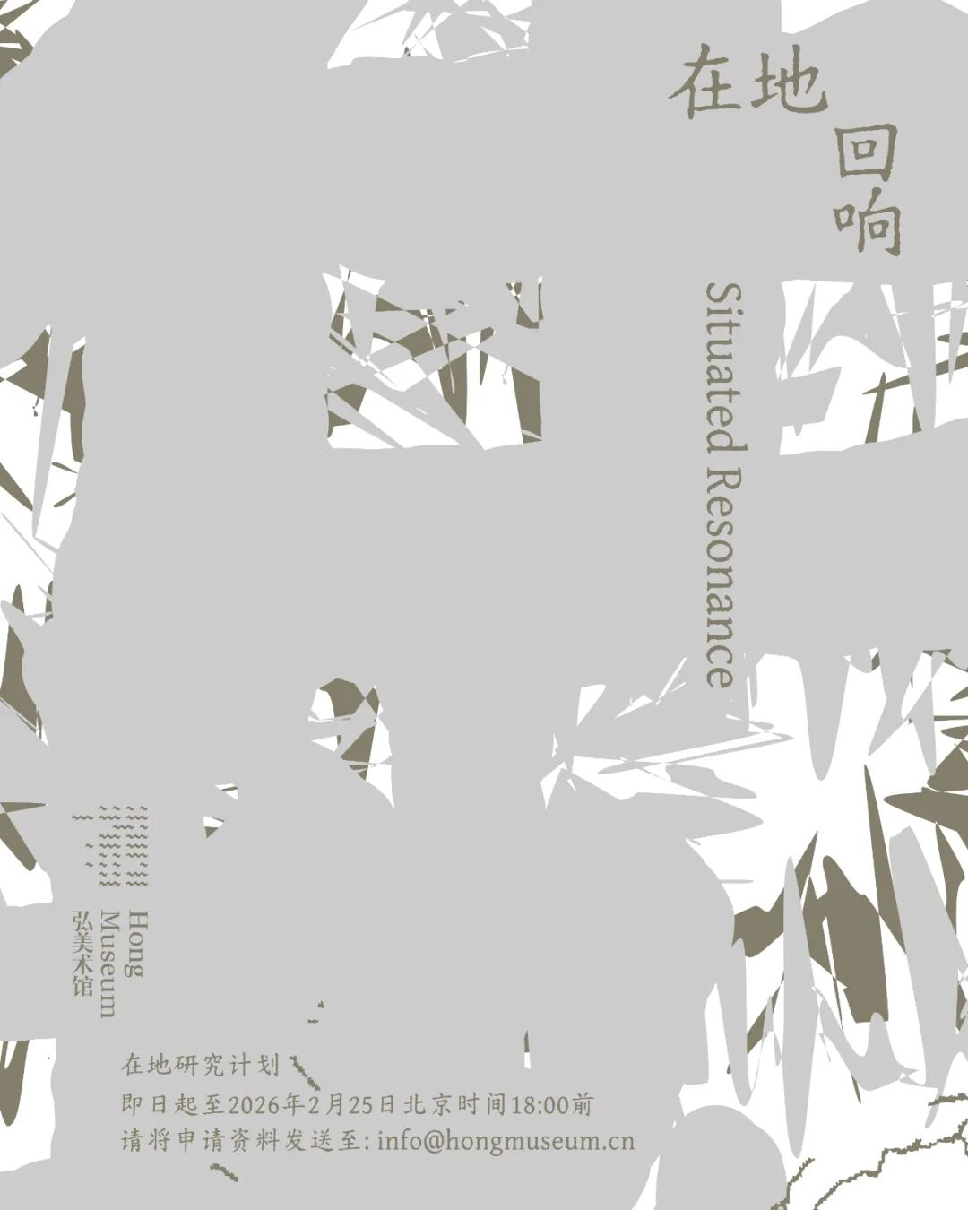

Poster Design: Related Department

**Hong Museum will officially launch the "Situated Resonance" Wenzhou Research Sponsorship Program in 2025, establishing it as the museum's annual flagship initiative from this year onward. This program aims to sustain a focus on the exploration and production of situated knowledge, building an open dialogue platform that interconnects art, social sciences, and the public.**

We believe knowledge is not abstract truth suspended in mid-air（detached from reality）, but voices carrying the warmth of the land and the body.

This sponsorship program invites "situated" researchers to step into the everyday life and history of Wenzhou, to listen and think from the textures of lived experience, transforming local experiences into new languages and imaginations, thereby evoking responses and resonances that cross geographical boundaries.

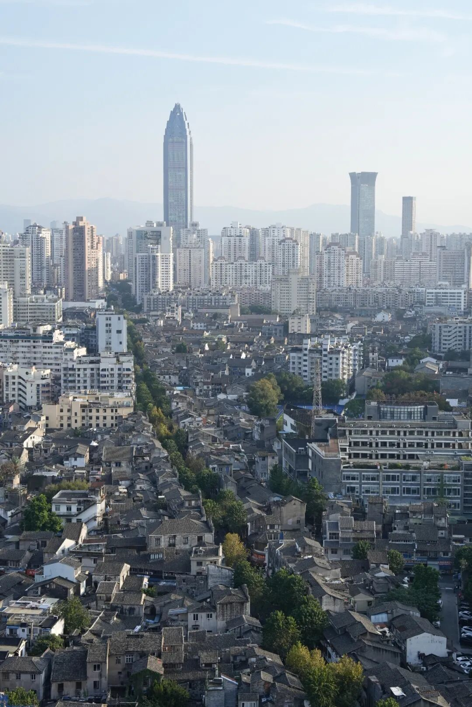

A distant view of Wenzhou's old city; the main street pictured is Jiefang Street.

In the two years since its (Hong Museum) opening, Hong Museum (we) has successively presented exhibitions, such as (including) the slightly (subtly) provocative "The Forebears Are Born" examining Wenzhou's traditional social structures; "Eleven Kinds of Beds" exploring the relationship between body and space; "The Currents We Carry" drawing inspiration from local shoe factory culture; and "Mama" scrutinizing global colonial issues. Building on this foundation, we will continue the residency program "The Plan of Going Home Residency Program" in 2025, focusing on local food, and plan to launch a group exhibition on food systems curated with te editions in January 2026, re-examining our rewritten relationships with food, body, and community.

Through the 2025 "Situated Resonance" Wenzhou Research Sponsorship Program, we hope to further expand the social functions of local art institutions, break down the boundaries between art, social sciences, and public participation, and construct a more experimental and open site for knowledge production and exchange.

**（**This sponsorship program was**）Initiated by Hong Museum, which also established a committee to form a continuously evolving collaborative network.** The 2025 "Situated Resonance" Wenzhou Research Sponsorship Program Committee is jointly formed and promoted（driven） by anthropologist  **Xiang Biao**, University of Edinburgh Anthropology Lecturer **FengJiang Jiazhi**, artist  **Sun Yitian**, art publishing collective **te editions**, founder of Related Department **Meng Xin**, and Director of Hong Museum **Pan Hongzheng**. We now publicly call for researchers with genuine interest and independent thinking on this subject.

Whether you are a **scholar, writer, designer, filmmaker, curator, artist, or any other type of cultural practitioner**, if you hold a sustained curiosity about Wenzhou, you are sincerely welcome.

We will provide selected researchers with a sponsorship grant of **RMB 50,000 (50,000 CNY)** to support their local research.

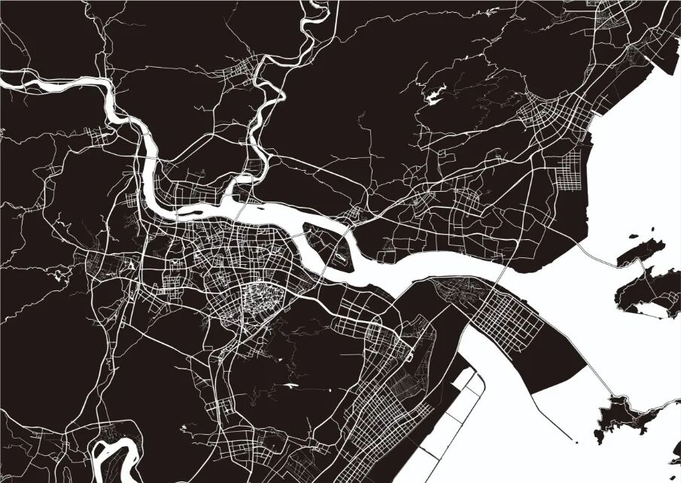

"Situated Resonance"

Wenzhou Research Sponsorship Program

Wenzhou, renowned both within China and globally for its unique "fluidity," serves as the focal site for this research program. How does a group famed for its "mobility" continuously practice "topophilia" and creatively reconstruct their sense of belonging? How does global spatial expansion, in turn, reshape local landscapes and emotional structures?

The Jin Dynasty geomancy master Guo Pu designed the city based on Feng Shui principles, referencing the Big Dipper, the Twenty-Eight Mansions, Yin-Yang, and the Five Elements to arrange the city's plan and functional layout, creating the unique pattern of a "Mountain-Water Dipper City."

The surrounding mountains endowed this place with deep-rooted stability for clans, beliefs, and customs; while the river networks connecting to the sea constantly catalyzed fluidity characterized by pioneering, diaspora, and cross-cultural integration. Throughout the long flow of history, the city's fate and its spatial form have always mirrored each other, echoing Guo Pu's prophecy: "Walls winding around mountains, ensuring lasting peace and stability" and "Wenzhou's vitality will flourish a millennium from now."

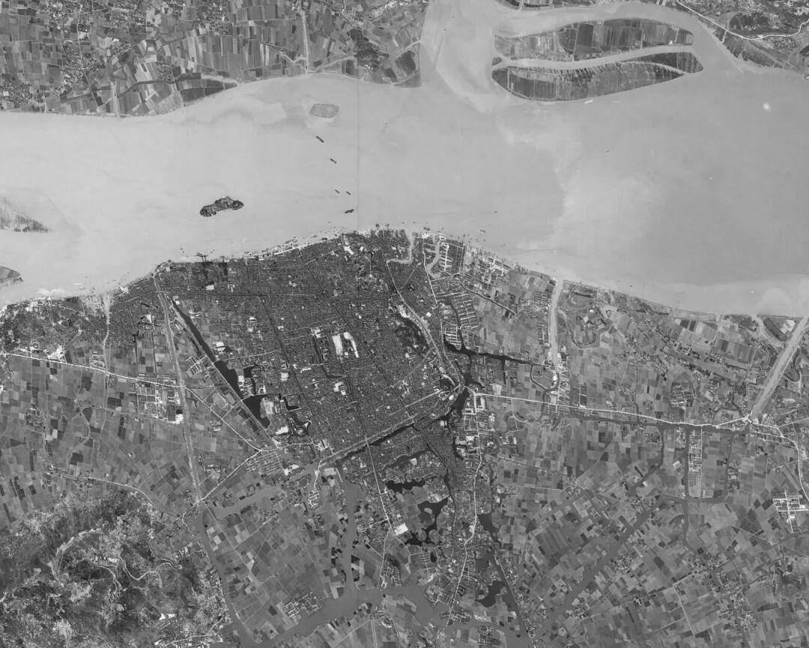

Wenzhou urban area photographed by a US satellite in 1965

Still largely consistent with the old city design by Guo Pu from the Eastern Jin Dynasty.

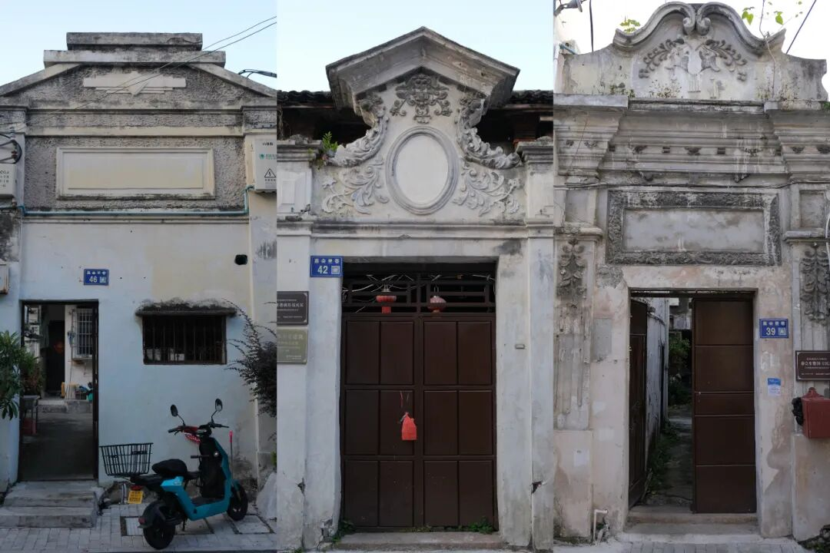

Wenzhou's old city area primarily consists of 'cheng' (walled areas), 'fang' (blocks), and 'xiang' (lanes).

Photo taken in Jiahui Lane; Republican-era residences often feature Baroque-style gate towers.

In the Wenzhou dialect, "Jiahui" sounds similar to "Jiaohui" (church), and many church activities were held here in the past.

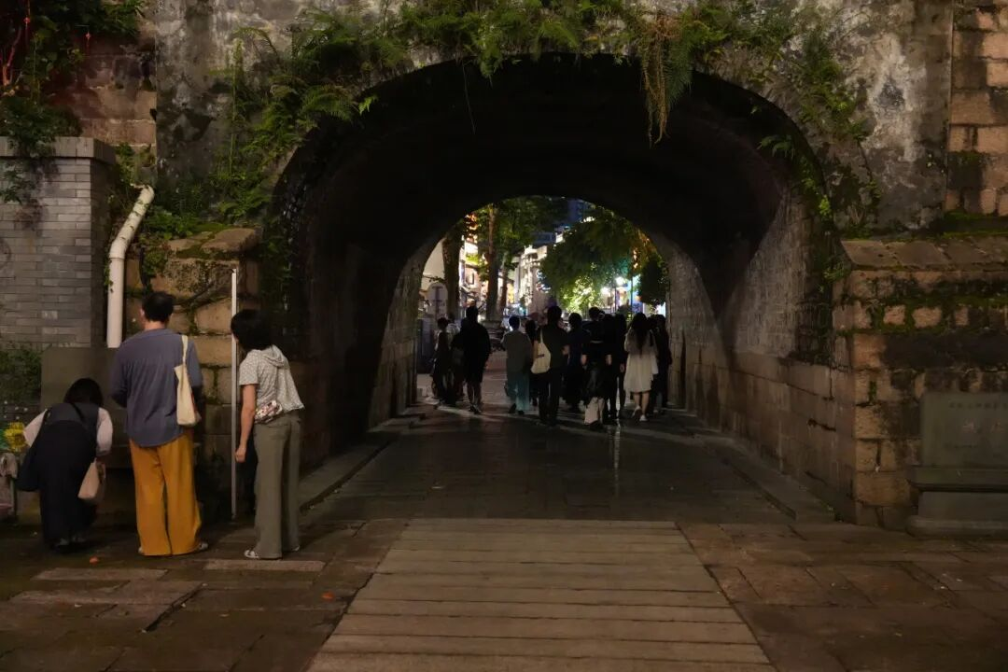

"Eleven Beds" exhibition, second unit activity

------ "Walking the Ancient Wenzhou City Sensing the Twenty-Eight Mansions"

Looking from the depth of historical sociology, this is the birthplace of the Southern Song "Yongjia School." The philosophical sediments of "**combining righteousness and benefit**" (emphasizing the balanced unity of moral principles and practical utility) and "**applying knowledge for social utility**" (focusing on social realities, advocating practical solutions to social problems) cultivated a cultural gene of mercantile ethics and practical wisdom, becoming a theory of "spatial practice" for effective action in the broader world, forming a unique social foundation of grassroots self-organization and market networks.

In the 1980s, as one of China's first coastal open cities, Wenzhou started from "front store, back factory" family workshops, gradually developing into the "Wenzhou Model" summarized by sociologist Fei Xiaotong—an endogenous development path centered on private economy, market orientation, and regional production-marketing networks.

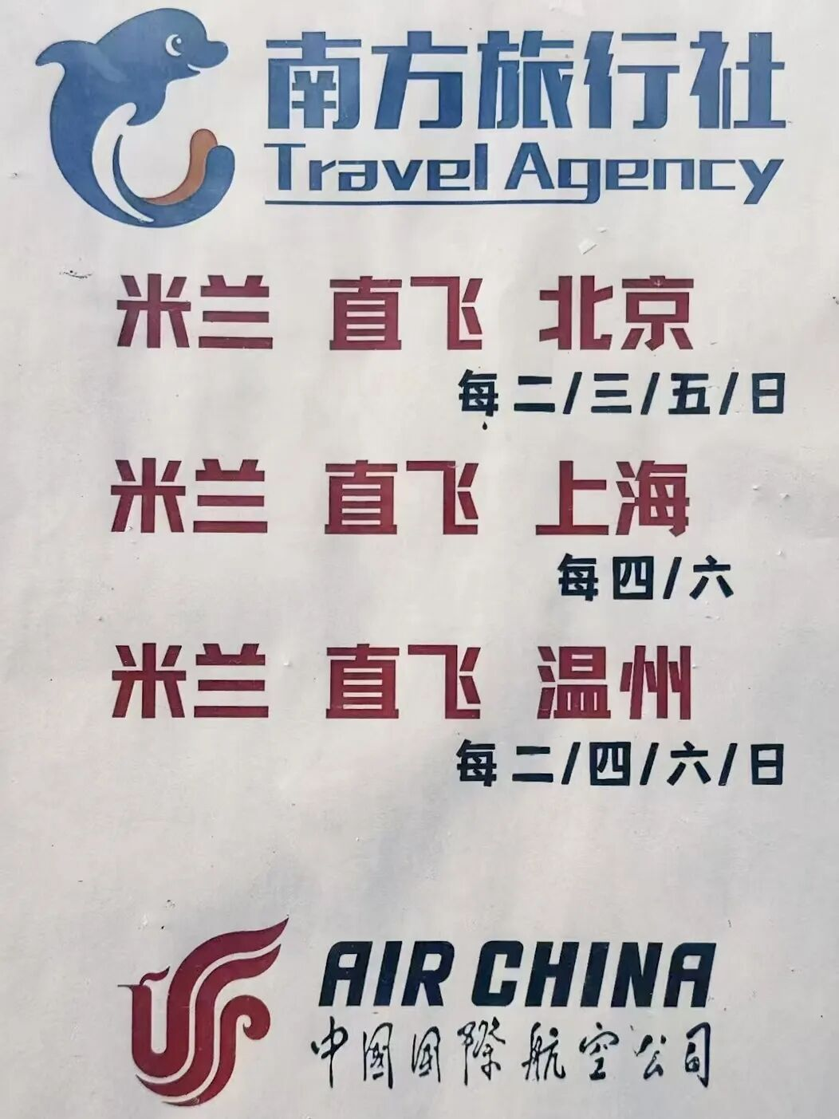

Direct flight routes between Milan and domestic Chinese cities (Beijing, Shanghai, Wenzhou) launched by Air China.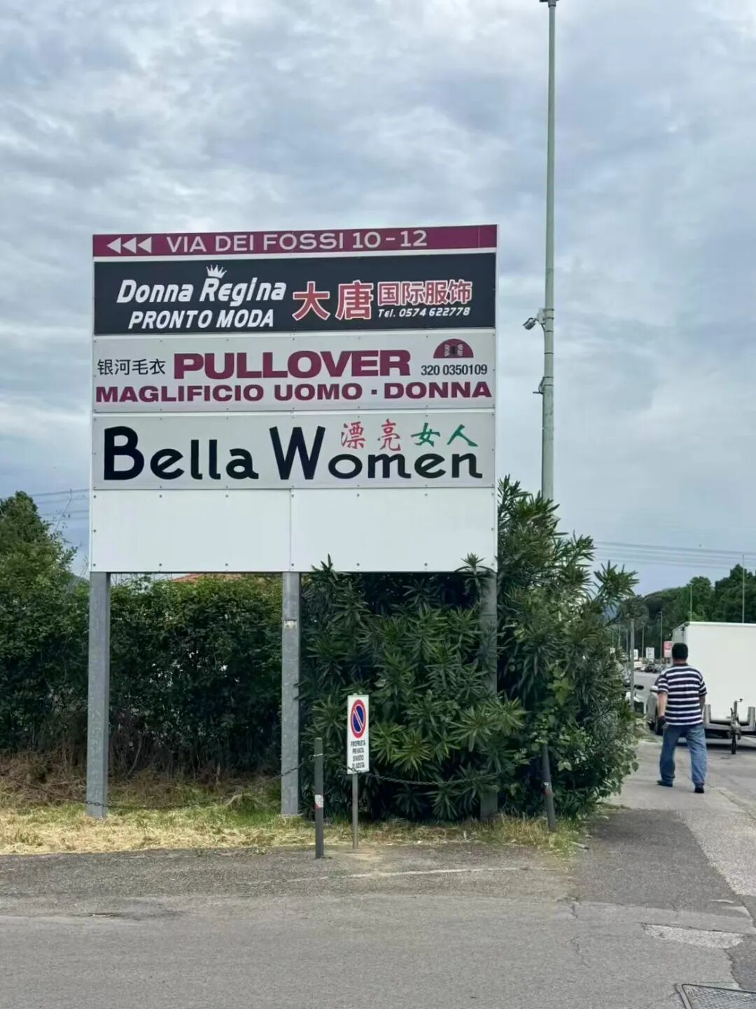

Street signs in Prato; many migrants from Wenzhou relocated labor-intensive textile industries to Italy.

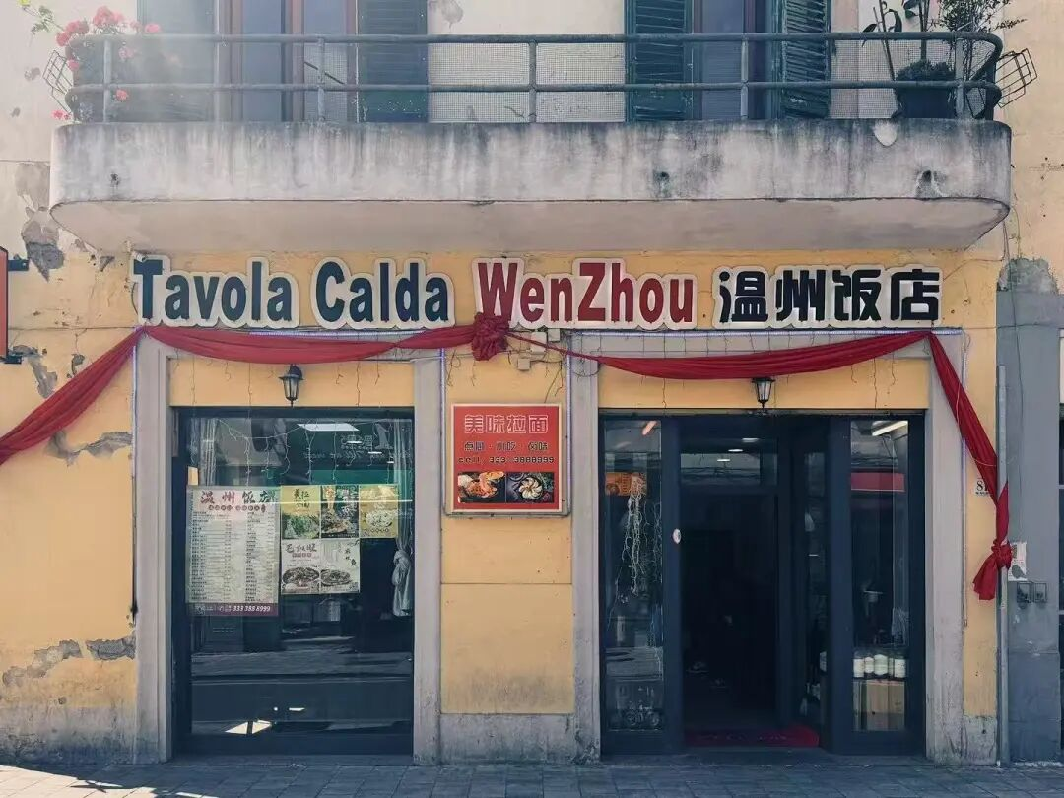

A Wenzhou restaurant on the streets of Prato, Italy

In this process, local production clusters based on kinship, geography, and even faith seamlessly connected with grassroots spatial expansion initiated by the people. Hundreds of thousands of Wenzhou people went global, establishing commercial footholds in Paris, Prato, Milan, New York, and elsewhere, forming a unique "Wenzhouese Economic Circle." The traditional social structure of clans did not fade away with global population migration and modernization but transformed into trust capital and credit systems supporting global business networks.

Simultaneously, the wealth and vitality created by the highly export-oriented private economy continuously fed back into the local urbanization process: a landmark case is the 1987 Wenzhou Yongqiang Airport—China's first civilian airport funded by private capital, where Wenzhou chambers of commerce proactively raised funds and coordinated, contributing over 60 million CNY in social capital out of the total 132 million CNY construction cost. The participation of private capital in shaping transportation hubs, urban renewal, and public landscapes propelled Wenzhou's evolution from a local city to a modern metropolis with global connectivity in a self-reinforcing manner.

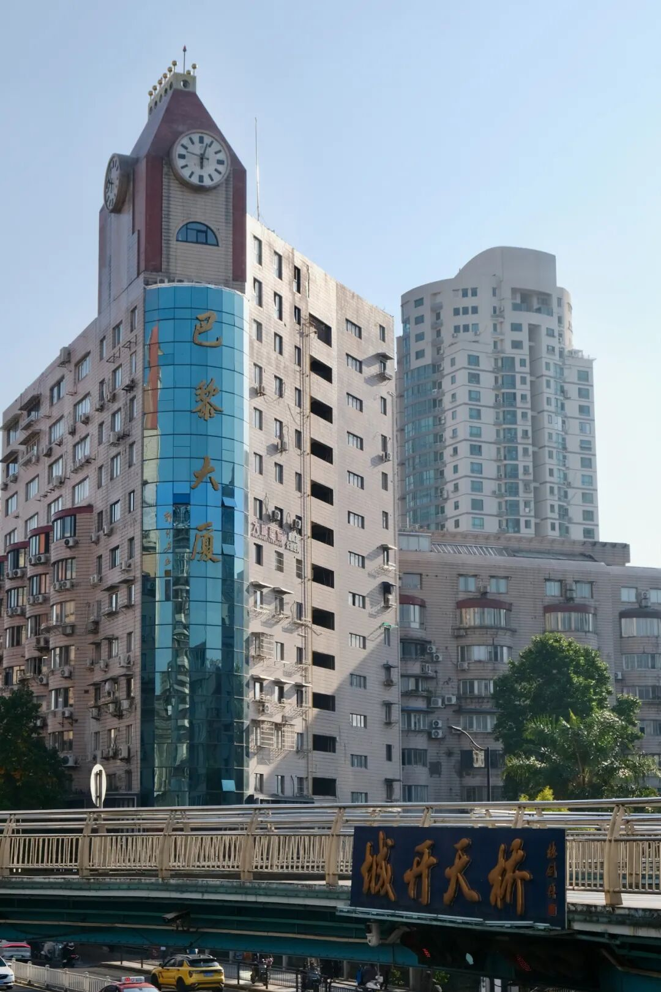

Bali Dasha (Paris Mansion) built in 1990 at the intersection of Renmin Road in the city center,

and the Chengkai Pedestrian Bridge built in 1995

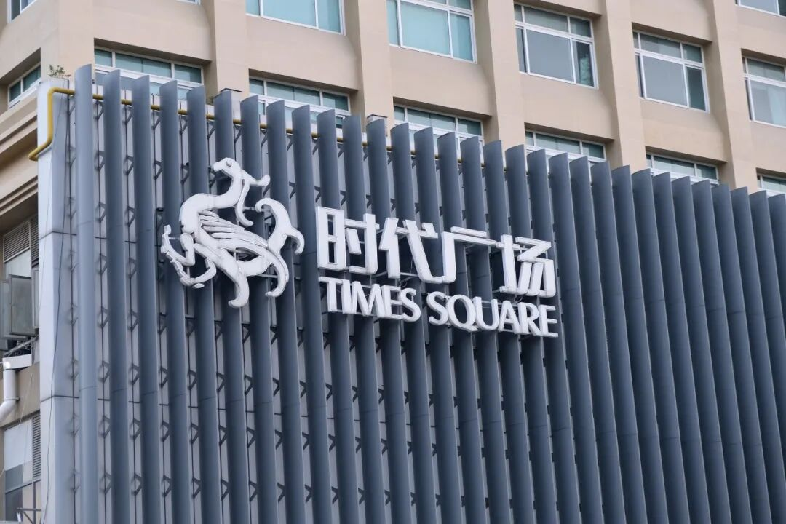

Times Square, Wenzhou's earliest upscale department store, began operation in 2002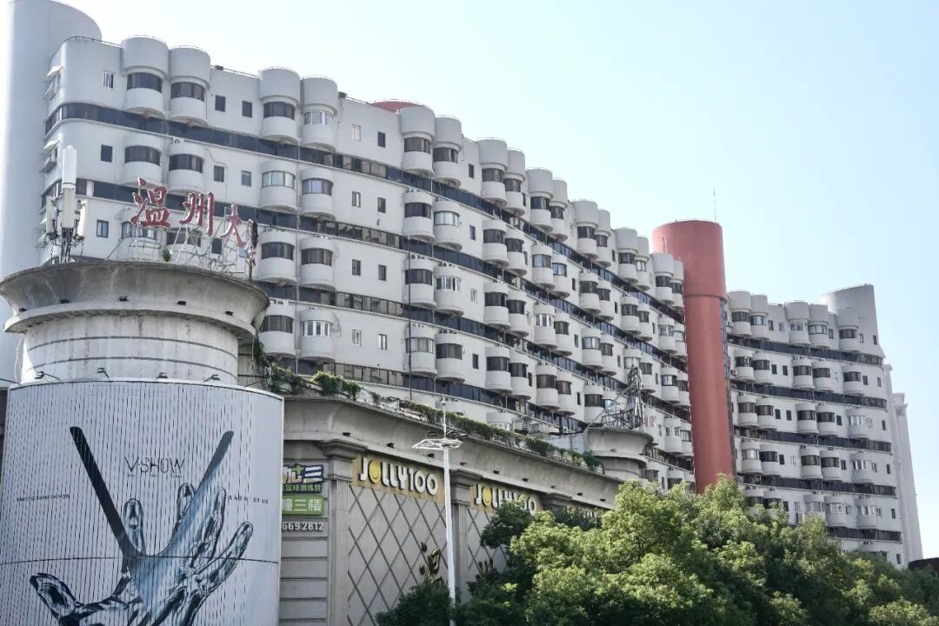

Wenzhou Mansion, a residential building designed by Hong Kong architects, built in 1995.

Furthermore, dense religious architecture and a pluralistic landscape of beliefs constitute a social capital reserve and spiritual support system matching the "private economy and global flow," providing an informal institutional foundation for the efficient global resource allocation and reduced transaction costs of the "Wenzhouese Economic Circle."

Buddhism and Taoism together form Wenzhou's traditional belief systems.

Christianity, introduced in the 19th century, developed rapidly, earning Wenzhou the nickname "China's Jerusalem."(Since the Christianity introduction in the 19th century, it has rapidly developed, giving rise to the region being called "the Jerusalem of China.")Ancestral halls, Buddhist temples, Taoist temples, Christian churches, and folk belief shrines often stand side by side, forming (collectively shaping) a longstanding, diverse, and co-existing local religious landscape.

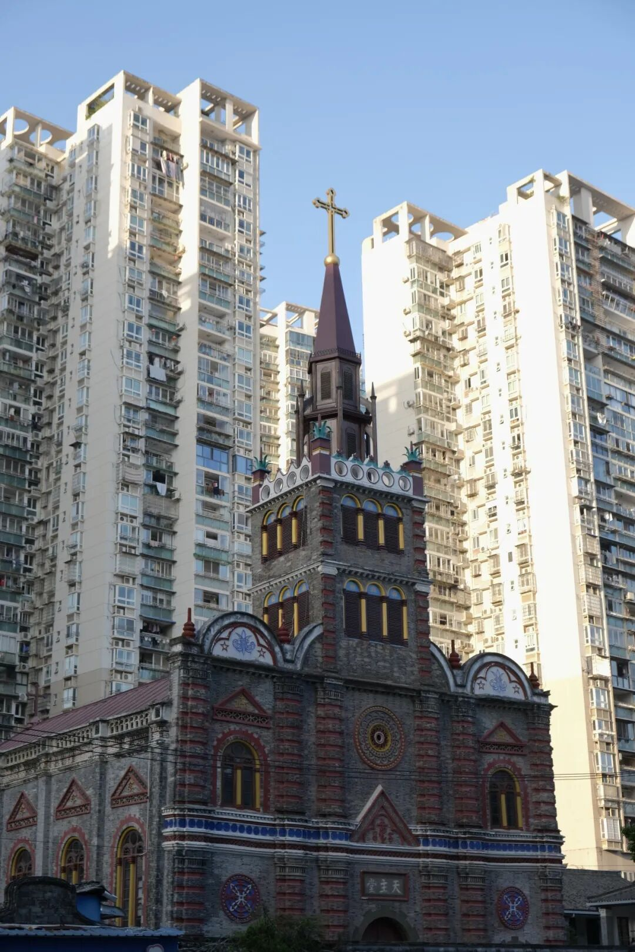

The Catholic Cathedral in Wenzhou's old city, surrounded by residential buildings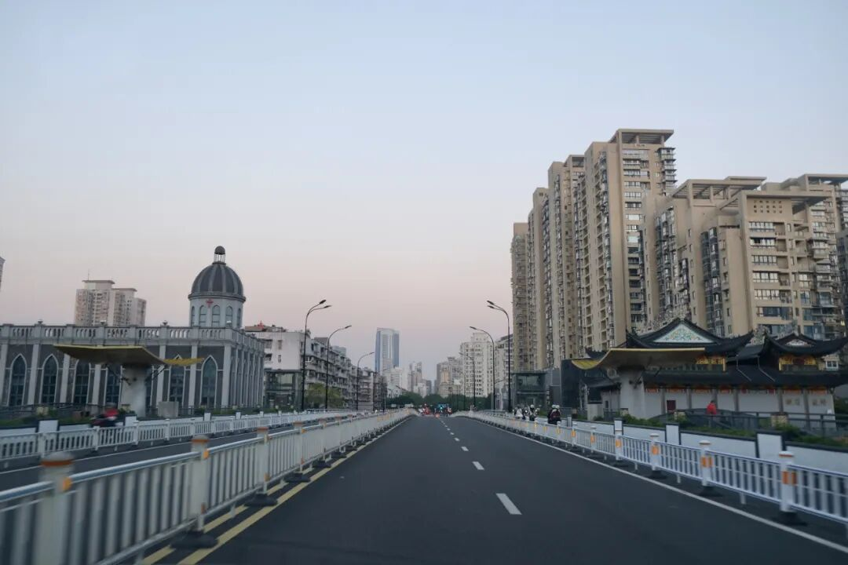

A church and a Taoist temple stand on opposite sides of Longkang Bridge in Lucheng District.

Since the Reform and Opening-up, with its profound historical sociality, actively and often in "informal" ways, participated in and shaped its development path(**Wenzhou** drawing on its profound historical sociality, has actively and often informally participated in shaping its developmental path), demonstrating a kind of grassroots, continuous creative tension. Wenzhou is far more than an economic symbol famous for its global trade networks; it is also a social arena of clashing ideas and a "Southeastern Slice" for understanding modern China.

Wenzhou is a living specimen constantly writing itself anew through the dialectic of the "local" and the "global," a cultural field full of research potential. We seek to deeply understand the historical and social context of Wenzhou, using unique individual perspectives to uncover global narratives hidden within subtle daily routines. We hope to reinterpret the unique texture and spirit of this city from concrete local experiences, embarking on explorations that are both grounded and intellectually innovative.



**Application Details**

***Profession/Field***

Including but not limited to scholars, writers, designers, filmmakers, curators, artists, and other cultural practitioners.

***Number of Selected Researchers***

1 individual/group

***Deliverables***

Physical outcomes, including but not limited to: thesis, publication, renovation project, public program, exhibition, film/video, installation, etc.

*****We Provide*****

· A sponsorship grant of 50,000 CNY

· Space to support the implementation of the research project

· Research support, local network coordination, and discussion/assistance in creative and curatorial development

*****Researchers Are Required To Complete*****

· A minimum residency period of 7 weeks

· Submit a progress report every three months

· Deliver at least 1 public lecture and participate in planning 1 to 2 public events

· Submit complete documentation of the research process and a final report ------If the primary output is text-based, the text volume should be approximately 50,000 words (approximately 35,000-50,000 words in English). If the primary output is a practical project (e.g., film, installation, spatial renovation), submit a research document of approximately 15,000 words (approximately 10,000-15,000 words in English) presenting the research methods, fieldwork process, and logic behind the work's generation

· The output or implementation of core outcomes shall be determined in consultation with Hong Museum

· All the above must be completed within the sponsorship period of one calendar year

***How to Apply***

-Please submit application materials to: info@hongmuseum.cn by 18:00 (UTC+8), 25 February 2026.

-Email subject: "2025 Situated Resonance + Name + Research Proposal Title"

***Application Materials***

1. CV
2. 1-2 **recommendation letter**
3. Motivation Letter
4. Research Project Proposal (including research direction, detailed budget, timeline, etc.)
5. Portfolio and other supplementary materials

***Selection Process***

The sponsoring organization, the Hong Museum, will conduct the initial screening of applications and convene the committee for joint decision-making. The results will be announced on a specific date in March 2026.

For any inquiries, please contact the official Instagram account for detailed consultation: hongmuseum_official

descript



**"Situated Resonance"**

**Wenzhou Research Sponsorship Program**

**Committee Members**

The 2025 "Situated Resonance" Wenzhou Research Sponsorship Program Committee is jointly formed by anthropologist **Xiang Biao**, University of Edinburgh Anthropology Lecturer in **FengJiang Jiazhi**, artist **Sun Yitian**, art publishing collective **te editions**, founder of Related Department **Meng Xin**, and Director of Hong Museum **Pan Hongzheng**. Coming from fields such as anthropology, art, sociology, design, and communication, they are often active in cities including London, Edinburgh, Berlin, New York, Shanghai, and Wenzhou.

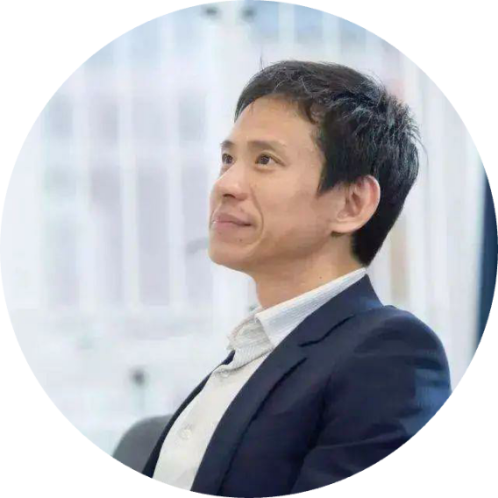

**Xiang Biao**

Anthropologist, Professor of Social Anthropology at Oxford University, Director at the Max Planck Institute for Social Anthropology, Germany. Born in 1972 in Wenzhou, Zhejiang. Xiang Biao first studied the "Zhejiang Village" on the urban-rural fringe of Beijing, later pursued studies overseas, conducting research in Australia and other places, resulting in works like "Transcending Boundaries" and "Global 'Body Hunting'". Awarded the William L. Holland Prize in 2012, the British Academy Mid-Career Fellowship, among others.

In the preface to "Global 'Body Hunting'", Xiang Biao proposed that as a Chinese scholar, he hopes his research topics are not merely so-called China studies closely related to his identity, but that he should, like anthropologists from other countries, engage in the writing and research of overseas ethnography.

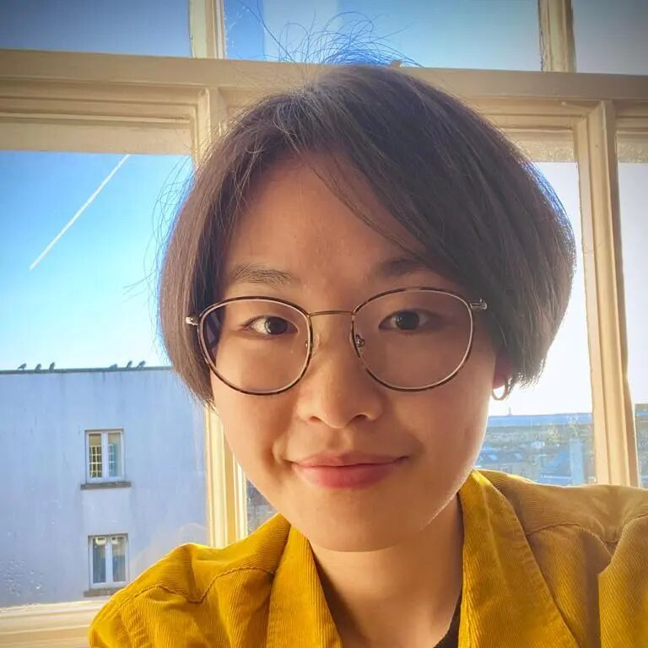

**FengJiang Jiazhi**

Born in 1990 in Wenzhou, Zhejiang, currently Lecturer (Assistant Professor) in Anthropology at the University of Edinburgh. She previously held postdoctoral researcher at the Max Planck Institute for the Study of Religious and Ethnic Diversity in Germany and at Princeton University. Based on long-term fieldwork in southeastern coastal China and rural central China, she focuses on issues of labor, ethics, care, mobility, and social change. Her first ethnographic monograph delves into the evolution of contemporary grassroots philanthropy and associational life. Awarded the William L. Holland Prize in 2021 and the Royal Society of Edinburgh Personal Research Fellowship in 2022. Beyond writing, she is also committed to exploring multimodal and public social science.

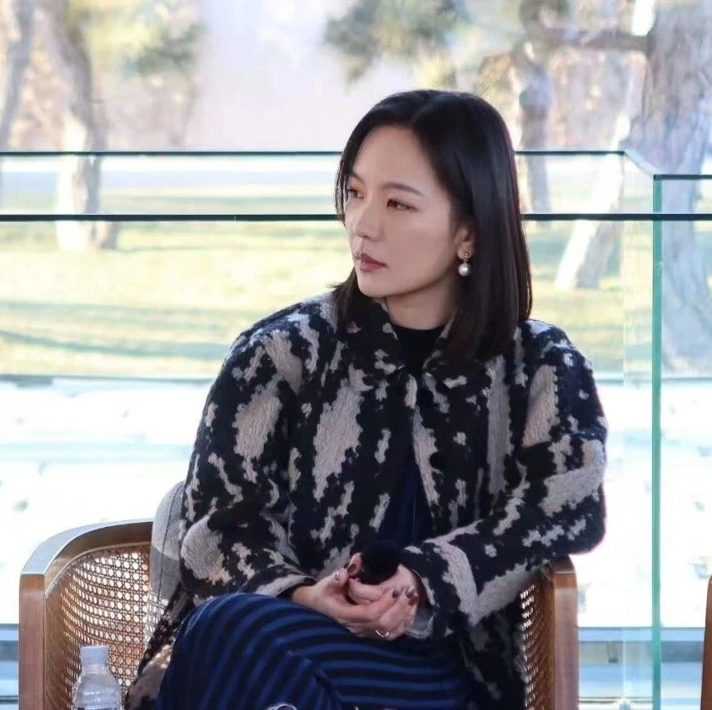

**Sun Yitian**

Artist, born in 1991 in Wenzhou, Zhejiang. Graduated from the Oil Painting Department of the Central Academy of Fine Arts in 2015 and received her Master's degree from the same department in 2018. Currently pursuing a Ph.D. in the School of Humanities at Tsinghua University. Her work involves painting, installation, performance, and fashion crossovers. Her work uses "objects" as an entry point, subtly hinting at the labor and production behind them, revealing the internal mechanisms of consumer society.  
Sun Yitian's works often employ photographic realism to examine temptation and fear, the secrets and increasingly fragile connections between the two, and sculptural "materiality," which together constitute her creative themes.

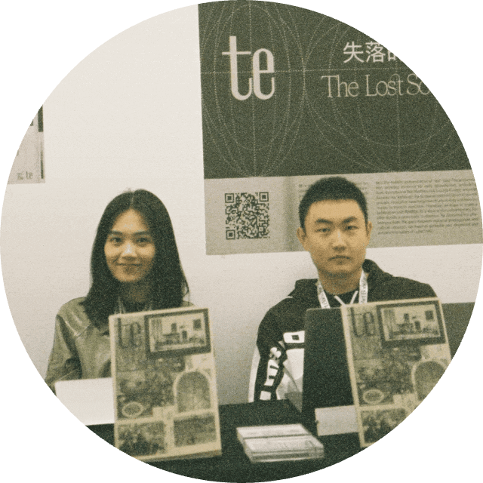

**te editions**

**Qin Kechun, Guo Hetian**

te editions is a publishing collective active in New York, aiming to explore diverse possibilities at the intersection of art and humanities. They observe historical and contemporary social landscapes with pluralistic, micro-perspectives, focusing on the fusion, collision, and transformation within cultural flows. With "curation on paper" as their editorial philosophy, they integrate interdisciplinary perspectives into research and practice, stimulating new discussions.

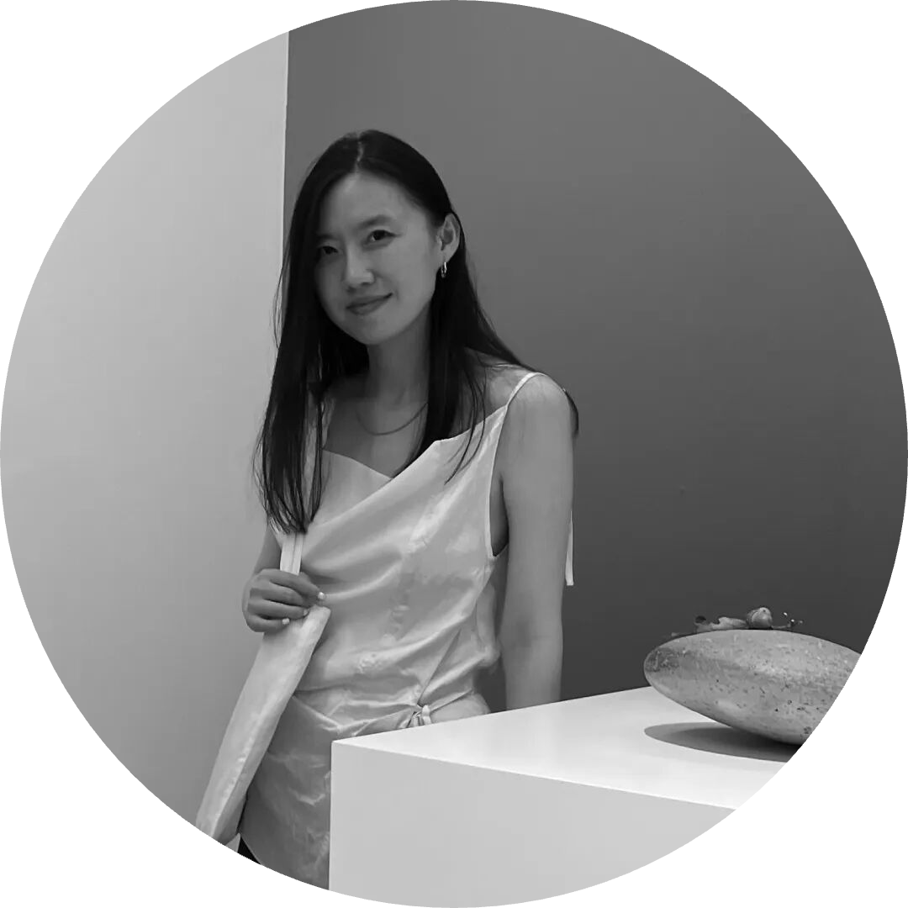

**Meng Xin**

Founder of Related Department, currently works in New York and Shanghai. Focuses on creative mechanisms within the changing context of design, conducting research-based practice along the vein of design's geographical narratives, while also engaged in design education and critical writing on design. Works have been exhibited at the Power Station of Art (Shanghai), Asia Culture Center (Gwangju), Queens Museum (New York), West Bund Art & Design Fair, San Francisco Design Week, China Academy of Art, among others. Works have received various international awards and are held in collections including the Asia Art Archive, T Museum, Rhode Island School of Design, University of Pennsylvania, Yale University Library, Asymmetry Art Foundation.

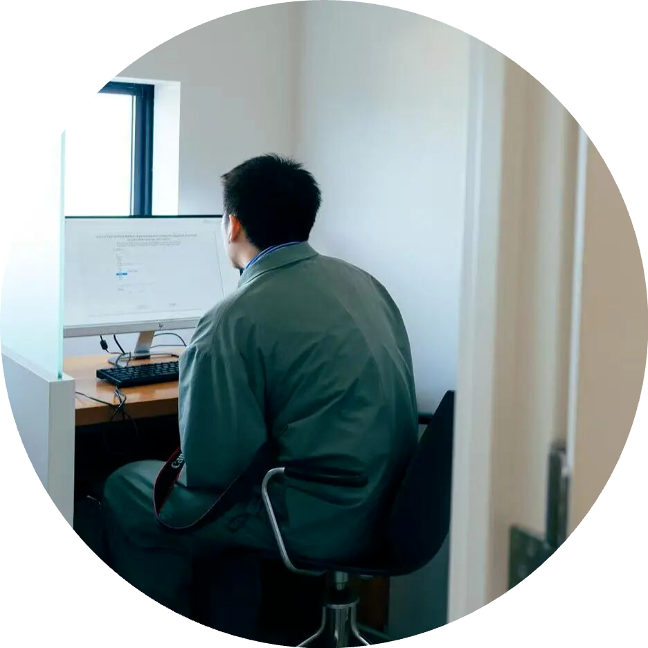

**Pan Hongzheng**

Director of Wenzhou Hong Museum. Formerly a Research Assistant at The Chinese University of Hong Kong, holds an MPhil in East Asian Studies from the University of Cambridge, UK, an MSc in Sociology from the London School of Economics and Political Science, and an MRes from SOAS, University of London. Having moved between various places, and once feeling shy to speak about his local identity, he now begins to try cooking the sweet, sour, bitter, and spicy flavors of this city.

Museum Team: Bao Ziyou, Wang Yaying, Xia Ziwei

**We extend our sincere gratitude to all colleagues who provided suggestions and assistance for this program!**

**And a warm welcome to all fellow travelers who pay attention to and apply for this program!**

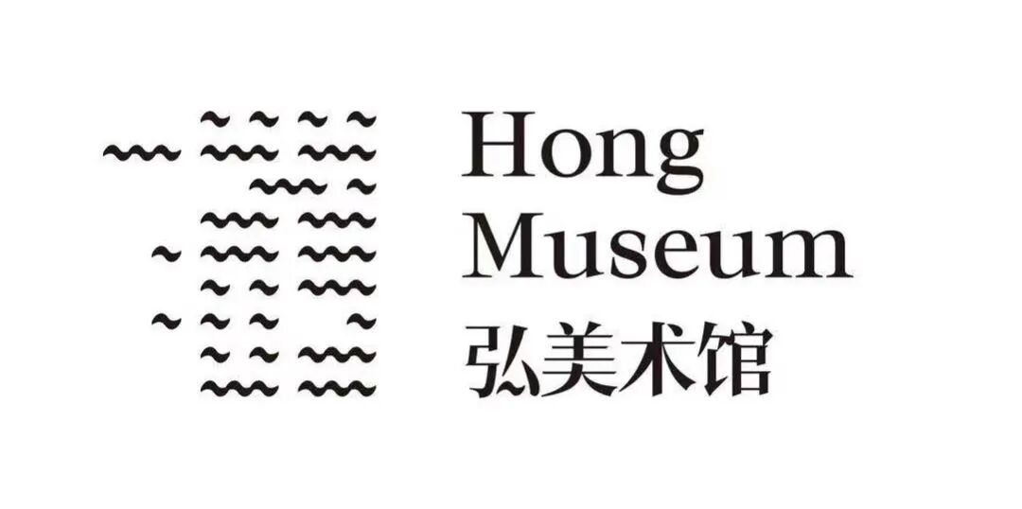



**Current Exhibition**

**Exhibition: Mama**





**Past Exhibitions**